Single Lane Highway

Problem Description
Certain number of cars are passing a single lane road. Speeds of all cars vary. It is easy to see, that depending on the speeds of the cars various groups will be formed.
Being a single lane road passing/overtaking is not allowed. Given speeds of cars, calculate how many groups can be formed if all possible permutations are taken into account. Refer example1 for better understanding.
Print number of groups divided by the number of permutations.

Constraints
0 <= N < 10 ^ 5
0 <= speed of individual vehicle < 10 ^ 9

Input
First line contains an integer N, which denotes the number of vehicles
Second line contains N space separated integers which denotes the speed of individual vehicle.

Output
Print number of groups divided by the number of permutations rounded upto 6 decimal places.

Time Limit
1

Examples
Example 1
Input
3
10 20 30
Output
1.833333
Explanation:
So all possible permutations are:
{10 20 30}
{10 30 20}
{20} {10 30}
{20 30} {10}
{30} {10 20}
{30 20} {10}
So here there are total 6 permutations, and total number of groups are 11.
So, output is 11/6 = 1.833333

Example 2
Input
4
56 78 13 92
Output
2.083333
Explanation:
So here there are total 24 permutations,
For example:
{56 78 13 92}
{92} {13 78 56}
{56} {13 92 78}
{78 92} {13 56}
.
.
So on and so forth. The total number of groups are 50.
So, the output is 50/24 = 2.083333

Count Palindromes

Problem Description
A contest closes in n days hh hours, mm minutes and ss seconds. Given two values of n, how many palindromes of the format nhhmmss would we find in the indicated interval?
A string is said to be palindrome if it reads the same backwards as forwards.

Constraints
n2 - n1 <= 10

Input
One line containing two integer n1 and n2, where n1<n2

Output
One integer representing the number of palindromes in this countdown interval

Time Limit
3

Examples
Example 1
Input
1 2
Output
472
Explanation
We need to check the numbers 1000000 through 2235959 including only numbers where the last 6 digits correspond to times. We find 472 such numbers: 1000001, 1001001, 1002001, 1003001, 1004001, ..., 2231322, 2232322, 2233322, 2234322, 2235322
Example 2
Input
0 2
Output
708
Explanation
There are 708 palindromes: 0000000, 0001000, 0002000, 0003000, 0004000, ..., 2231322, 2232322, 2233322, 2234322, 2235322

Equalize Weights

Problem Description
There are N bags. Each bag contains different number of goods. Goods can be of different weights. The goal is to equalize the weights in the bags subject to constraints explained below. Also, it is guaranteed that the bags can always be equalized with same total weight.
- Original number of goods in the bag should be same before and after equalization
- Any number of swaps required to do equalization, are permitted
Once the weights are equalized one needs to adhere to output specification to print out the result.
The output specification is as follows
- The contents of the Bag that contains the lightest weight should be printed in the first line
- The next lightest Bag contents should be printed on the second line
- So on and so forth, until all Bags along with their contents are printed
- Contents within the Bag must be printed in non-decreasing order
Refer example section for better understanding of constraint and print order

Input
First line contains an integer N denoting number of bags
Next 2N lines, each contain the following
First line contains single integer G denoting the number of goods in a bag
Second line contains G space separated integer which correspond to weight of goods in that bag

Output
Identify which bag needs to go on first line and print its contents on first line by adhering to output specification mentioned above
Similarly, identify which bag needs to get print on next N-1 lines and print their contents according to output specification mentioned above
Refer Example section for a better understanding of how to print the output

Constraints
0 < number of bags <= 20
0 < number of goods in each bag <= 20
0 < weight of any individual goods <= 10 ^ 4

Time Limit
1

Examples
Example 1
Input
3
2
6 13
3
20 7 10
1
4
Output
4 6 10
7 13
20
Explanation
There are 3 bags.
First bag contains 2 goods of weights 6kg, 13kg.
Second bag contain 3 goods of weights 20kg, 7kg, 10kg.
Third bag contains 1 goods of weight 4kg.
Bag1 = [6, 13] => total weight = 19kg
Bag2 = [20, 7, 10] => total weight = 37kg
Bag3 = [4] => total weight = 4kg

Step 1: swap goods of weight 6kg from bag1 and goods of weight 7kg from bag2.
Bag1 = [7, 13] => total weight = 20kg
Bag2 = [20, 6, 10] => total weight = 36kg
Bag3 = [4] => total weight = 4kg

Step 2: swap goods of 20kg from bag1 and goods of 4kg from bag3.
Bag1 = [7, 13] => total weight = 20kg
Bag2 = [4, 6, 10] => total weight = 20kg
Bag3 = [20] => total weight = 20kg

Weights of bags are now equalized to 20kg.

Now we need to print the contents of each bag. For that, first sort the goods in the non-decreasing order as below:
Bag1 = [7, 13]
Bag2 = [4, 6, 10]
Bag3 = [20]
Least weighted good is 4kg and its in Bag2. So, print Bag 2 contents in first line.
Next least weighted goods in the remaining bags is 7kg and its in Bag1. So, print contents of Bag1 in the second line.
Finally, print the contents of Bag3 on line 3.
Example 2
Input
3
2
160 340
3
40 448 12
2
300 200
Output
12 40 448
160 340
200 300
Explanation
There are 3 bags.
First bag contains 2 goods of weights 160kg, 340kg.
Second bag contain 3 goods of weights 40kg, 448kg, 12kg
Third bag contain 2 goods of weight 300kg and 200kg.
By the same procedure we will get the final weights in bags as follow:
Bag1 = [12, 40, 448]
Bag2 = [160, 340]
Bag3 = [200, 300]

Unlocker

Problem Description
A locker is comprised of one or more layers. Each layer can be rotated only in one direction. Odd numbered layers rotate in anti-clockwise direction (left to right), and even numbered layers rotate in clockwise direction (right to left).
You are given a locker, in the form of a matrix. The matrix will be rectangular in shape. The outer most layer of this matrix is layer1. In context of the diagram below, the numbers painted in red are layer1 and the inner numbers constitute layer2. Bigger matrices will have more layers.
One rotation defined as a given number moving in the neighbouring spot i.e. one spot left for clockwise rotation and one spot right for anti-clockwise rotation.
Number of rotations for each layer required to unlock the locker will be provided as input. Print the final unlocked matrix as output.

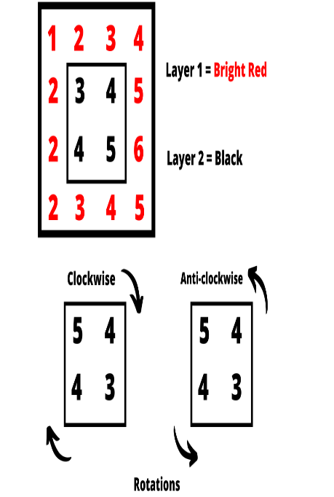

Constraints
1 < M, N <= 300
0 <= Numbers in matrix < 100
1 <= Number of rotations <= 10^9
M%2=0 && N%2=0

Input
First line contains two space separated integer M and N which denotes the number of rows and number of columns, respectively
Next M lines contain N space separated integers depicting the locked matrix
Last line contains L space separated integers, where L is the number of layers. Each number on this line denotes the number of rotations for every layer from 1 to L

Output
Print unlocked matrix

Time Limit
2

Examples
Example 1
Input
2 2
1 2
3 4
2
Output
4 3
2 1
Explanation:
There is only one layer. So, we have to rotate it in anti-clockwise direction with 2 rotations.

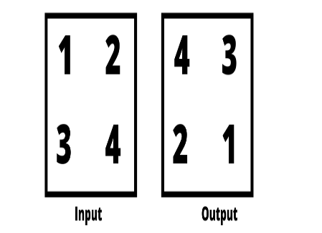

Example 2
Input
4 4
1 2 3 4
2 3 4 5
2 4 5 6
2 3 4 5
2 2
Output
3 4 5 6
2 5 4 5
1 4 3 4
2 2 2 3
Explanation:
Here we have to rotate layer1 in anti-clockwise direction with 2 rotations, and layer2 clockwise with 2 rotations.
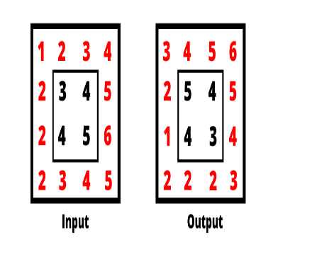

Subnetting

Problem Description
Given blocks of IPV4 CIDR addresses mapped to region name. Find which region does a given IP belongs to.
For better information about how CIDR works. Please refer to the following link.
https://en.wikipedia.org/wiki/Classless_Inter-Domain_Routing
The above link describes IPV6 CIDR also. However, in this problem we are dealing only with IPV4 CIDR only.
CIDR denotes a range of IP addresses. In our problem a region will be assigned a range of CIDRs. All such IP addresses falling in all such CIDR ranges, thus belongs to this given region. Consider an example below.
Example:
Range: 255.1.255.0/23 255.1.255.0/24 India
The CIDR 255.1.255.0/23 can have 512 hosts, and CIDR 255.1.255.0/24 can have 256 hosts. These are the individual ranges denoted by the first and the second CIDRs respectively. Similarly, in between these two ranges of CIDRs there will be other CIDR ranges like
255.1.255.1/23, 255.1.255.2/23 ................ 255.1.254.253/24, 255.1.254.254/24, 255.1.255.0/24
If the number of hosts in each such CIDR range mentioned above is calculated, then the total number of hosts in this overall range exceeds one billion. Now, your task is to find if the given IP address falls in this range.
Consider IP addresses: 255.1.254.123 and 255.1.250.23
Upon performing CIDR expansion, we realize that address 255.1.254.123 falls in this range and hence belongs to India region. However, address 255.1.250.23 does not fall in this region and hence does not belong to India region.
Give R IPv4 CIDR ranges, each belonging to a given region and N IP addresses, your task is to find out the region that a given IP address belongs to.

Constraints
1<=R <=100
1 <= N <= 5*10 ^ 4

Input
First line contains 2 space separated integers R and N, where R denotes number of IPv4 CIDR ranges and N denotes number of IP addresses
Next R lines contains two CIDR ranges (from range and to range) and region name. All three inputs are space separated
Next N lines, each contain a single IPV4 address

Output
For each IPV4 address, print the respective region name it belongs to. If it belongs to no region, then print “None” as output.

Time Limit
2

Examples
Example 1
Input
1 3
201.100.255.0/20 207.105.25.0/24 Bangladesh
202.251.245.56
202.255.245.230
207.106.245.230
Output
Bangladesh
Bangladesh
None
Explanation
Given R = 1, N = 3
The CIDR 201.100.255.0/20 can have 4096 hosts, and CIDR 207.105.25.0/24 can have 256 hosts. These are the individual ranges denoted by the first and the second CIDRs respectively. Similarly, in between these two ranges of CIDRs there will other CIDR ranges like
201.100.255.1/20, 201.100.255.2/20 ................ 207.105.24.253/24, 207.105.24.254/24, 207.105.25.0/24
Address 202.251.245.56 and 202.255.245.230 belong to this region. However, 207.106.245.230 does not belongs to this region.
So, output will be:
Bangladesh
Bangladesh
None
Example 2
Input
2 5
7.25.255.0/20 12.175.25.0/24 Taiwan
13.25.255.0/20 19.175.25.0/24 Japan
14.30.2.0
20.30.2.0
13.25.240.0
8.30.2.0
19.175.25.255
Output
Japan
None
Japan
Taiwan
Japan
Explanation
Given R = 2, N = 4
The CIDR 7.25.255.0/20 can have 4096 hosts, and 12.175.25.0/24 can have 256 hosts. These are the individual ranges denoted by the first and the second CIDRs respectively for Taiwan region. Similarly, in between these two ranges of CIDRs there will other CIDR ranges like
7.25.255.1/20, 7.25.255.2/20 ................ 12.175.24.254/24, 12.175.24.255/24, 12.175.25.0/24
Similarly for Japan region,
The CIDR 13.25.255.0/20 can have 4096 hosts, and 19.175.25.0/24 can have 256 hosts. These are the individual ranges denoted by the first and the second CIDRs respectively for Japan region. Similarly, in between these two ranges of CIDRs there will other CIDR ranges like
13.25.255.1/20, 13.25.255.2/20 ................ 19.175.24.254/24, 19.175.24.255/24, 19.175.25.0
Upon computation, we realize that addresses 14.30.2.0, 13.25.240.0 and 19.175.25.255 belong to Japan region and address 8.30.2.0 belongs to Taiwan region, while address 20.30.2.0 belongs to neither of the two regions.
Hence the output is,
Japan
None
Japan
Taiwan
Japan

